**List out the required processes to be coded along with the required flow charts**

Table of Contents

1.) User Registration Process 2

1.1) Flowchart Description 2

1.2) Key Steps: 2

2) User Login Process 3

2.1) Flowchart Description 3

2.2) Key Steps: 3

3.) Expense Tracking Process 3

3.1) Flowchart Description: 3

3.2) Key Steps: 3

4.) Geographic Area Monitoring 3

4.1) Flowchart Description: 3

4.2) Key Steps: 3

5.) Budget Allocation 4

5.1) Flowchart Description: 4

5.2) Key Steps: 4

6.) Alert Generation 4

6.1) Flowchart Description: 4

6.2) Key Steps: 4

7.) User Settings and Preferences 4

7.1) Flowchart Description: 4

7.2) Key Steps: 4

8.) Security and Data Privacy 5

8.1) Flowchart Description: 5

8.2) Key Steps: 5

9.) User Feedback and Support 5

9.1) Flowchart Description: 5

9.2) Key Steps: 5

10.) App Maintenance and Updates 5

10.1) Flowchart Description: 5

10.2) Key Steps: 5

# User Registration Process

* 1. Flowchart Description**:** This flowchart illustrates the steps involved in the user registration process, including user input, validation, and database storage.

## Key Steps:

* User provide personal details.
* User selects a username and password.
* Input validation and error handling.
* User data stored in the database.
* Confirmation of successful registration

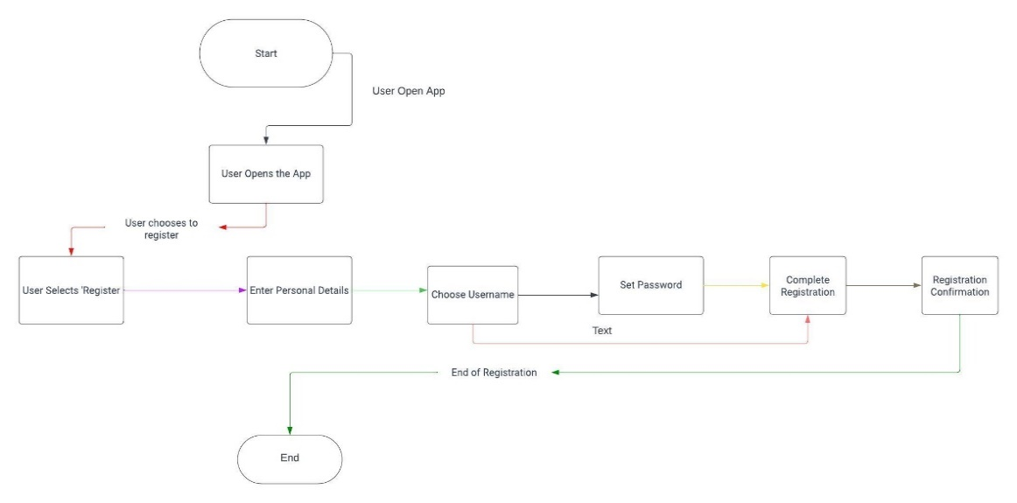

**Figure 1 User Registration Process**

# 2) User Login Process

2.1) Flowchart Description**:** This flowchart outlines the steps for user login,

including authentication and session management.

## 2.2) Key Steps:

* User enters username and password.
* Authentication against stored credentials
* Session management (E.g., generating session tokens).
* Redirecting authenticated users to the app dashboard.

# 

# Expense Tracking Process

3.1) Flowchart Description: This flowchart illustrates how users input and track their expenses using manual or voice recognition modes.

## 3.2) Key Steps:

* User select expense tracking mode.
* Manual entry or voice recognition input.
* Expense data validation.
* Storage of expense mode.
* Real-time calculation of expenses within geographic areas.

# Geographic Area Monitoring

4.1) Flowchart Description: This flowchart demonstrates the process of tracking user’s geographic locations and comparing them to predefined areas.

## 4.2) Key Steps:

* Continuous GPS tracking of user’s location.
* Comparison with predefined geographical zones.
* Detection of area changes.
* Real-time expense calculation within specific zones.

# Budget Allocation

5.1) Flowchart Description: This flowchart explains how the app suggests budget allocations based on spending patterns and goals.

## 5.2) Key Steps:

* Analysing user's spending history.
* Identifying unmet financial needs.
* Suggesting optimal budget allocations.
* User confirmation or modification of suggestions.

# 

# 6.) Alert Generation

6.1) Flowchart Description: This flowchart depicts how the app generates alerts for various scenarios, such as overspending or approaching budget limits.

## 6.2) Key Steps:

* Monitoring user spending in real-time.
* Evaluating spending against predefined limits.
* Generating alerts for specific triggers (e.g., overspending).
* User notification and alert management.

# User Settings and Preferences

7.1) Flowchart Description: This flowchart outlines the user interface for configuring notification preferences, security settings, and geographic zones.

## 7.2) Key Steps:

* User accessing settings menu.
* Configuring notification preferences.
* Updating security settings (e.g., password changes).
* Defining geographic zones and budgets.

# Security and Data Privacy

8.1) Flowchart Description: This flowchart details the app's security measures, including data encryption, access controls, and incident response.

## 8.2) Key Steps:

* Data encryption during transmission and storage.
* Role-based access control (RBAC).
* Incident detection and response procedures.
* User data protection and privacy policies.

# 

# User Feedback and Support

9.1) Flowchart Description: This flowchart shows how users can provide feedback, request support, or report issues within the app.

## 9.2) Key Steps:

* User access to feedbacks and support options.
* Submitting feedback or support requests.
* Appropriate routing of user inquiries.
* Response and resolution processes.

# App Maintenance and Updates

10.1) Flowchart Description: This flowchart outlines the procedures for app maintenance, software updates, and version control.

## 10.2) Key Steps:

* Scheduling maintenance and updates.
* Notification of downtime to users.
* Backup and restoration processes.
* Version control and release management.